Pawnee Community Unit School District #11
BOARD OF EDUCATION MEETING WORKSHEET
7:00 P.M., WEDNESDAY, SEPTEMBER 18, 2019
PAWNEE HIGH SCHOOL, PAWNEE, ILLINOIS
l. CALL TO ORDER

ROLL CALL
Secretary, Amy Wort
p _ Wort P - Ward P - Shelton A - Kern p _ Howard P — Starr P - McTaggart
Also present:
P - Scott Cameron, Superintendent P - Tim Kratochvil, Jr./Sr. High School Principal
P - Chris Hennemann, Grade School Principal

APPROVAL OF MINUTES
A Approval of minutes of the regular meeting on July 17, 2019.
Motion by Ward, seconded by Kern to approve the minutes of the regular meeting on July 17, 2019.
Y — Starr Y — Shelton Y — Kern Y — Howard
Y — Ward Y — Wort
6 — Yes 0 — No

EXECUTIVE SESSION (Closed Meeting)
(Time Entered: 6:07 p.m.)
A. Enter Executive Session
Motion by Howard, seconded by Wort to enter executive session for discussion of Matters relating to evaluation, employment and/or dismissal of staff.
Y — Shelton Y — Howard A — Kern Y - Ward
Y — Wort Y — Starr Y - McTaggart
6 — Yes 0 — No
- Discussion of evaluation, employment and/or dismissal of staff.
- Other matters appropriate for closed-session discussions.
- Return to open session. (Time returned to open session 6:49 p.m.).
Motion by Shelton, seconded by Ward to return to open session.
Y — Ward A — Kern Y — Wort Y — Starr
Y — Howard Y — Shelton Y — McTaggart
6 — Yes
PLEDGE OF ALLEGIANCE
Led by Ward

v. APPROVAL OF MINUTES
A. Approval of minutes of the August 21 regular board meeting.
Motion by Starr, seconded by Wort to approve the minutes of the August 21 ^{st} regular meeting.
Y — Starr | Y — Wort | Y — McTaggart | Y — Ward
Y — Shelton | A — Kern | Y - Howard
6

PUBLIC AND EMPLOYEE COMMENTS OR QUESTIONS
A. Public Forum. The opportunity for those present to address the board.
Name Subject:

PTO
B. Additional items for the current agenda. (These items may be added for discussion but not be added as an action item).

Vil. REPORTS FROM THE DISTRICT ADMINISTRATORS
Chris Hennemann, Grade School Principal
Tim Kratochvil, Jr.lSr. High School Principal
FINANCIAL REPORT Scott Cameron, Superintendent
Jill Hamilton, Business Manager

AGENDA ITEMS FOR DISCUSSION AND/OR ACTION
A. Approval of the list of current bills for payment.
Motion by Starr, seconded by Ward to approve the payment of the list of current bills as presented.
Y — Howard Y — Ward Y — McTaggart — Wort
A — Kern Y — Starr Y - Shelton
6 — Yes O-N0
B. Approve all hazardous crossings in District #11.
Motion by Shelton, seconded by Starr to approve all hazardous crossings in District #11.
Y — Ward Y — McTaggart Y - Shelton Y — Wort
Y — Starr A — Kern Y — Howard
6 - Yes
c. Approve to hire non-certified staff.
Motion by Shelton, seconded by Starr to approve to hire Sara Osborn as a paraprofessional.
A — Kern | Y — Ward | Y — Howard | Y — Starr
Y - McTaggart | Y — Shelton | Y — Wort
6 - Yes
D. Approve a temporary inter-fund loan from working cash to capital projects for $92,000.
Motion by Ward, seconded by Wort to approve a temporary inter-fund loan from working cash to capital projects for $92,000.
Y — Shelton Y — Howard Y — Ward Y — McTaggart
Y — Starr Y — Wort A — Kern
6 — Yes
- Approve resignation of Jr. High Softball Coach.
Motion by Shelton, seconded by Starr to approve resignation of Shelly Hinds as Jr. High
Softball Coach.
Y — McTaggart | Y — Shelton | Y — Wort | A — Kern
Y — Ward | Y — Howard | Y — Starr 6
- Approve resignation of Assistant Play Director.
Motion by Shelton, seconded by Starr to approve resignation of Kristle Williams as Assistant Play Director.
Y — Starr | Y — Wort | Y — McTaggart | Y — Ward
Y — Shelton | A — Kern | Y — Howard  6 — Yes
- Approve volunteer Jr. High and High School Girls Basketball Coach.
Motion by Shelton, seconded by Ward to approve Steve Kern as a volunteer Jr. High and High School Girls Basketball Coach.
Y — Ward | Y — McTaggart | Y — Wort | Y — Shelton
A — Kern | Y — Howard | Y — Starr
6 — Yes

ADJOURNMENT
Motion by Shelton, seconded by Starr to adjourn the meeting at 7:46 p.m.
A — Kern Y — Wort Y — Howard Y — Starr
Y - Ward Y — Shelton Y — McTaggart
6 - Yes 0 — No
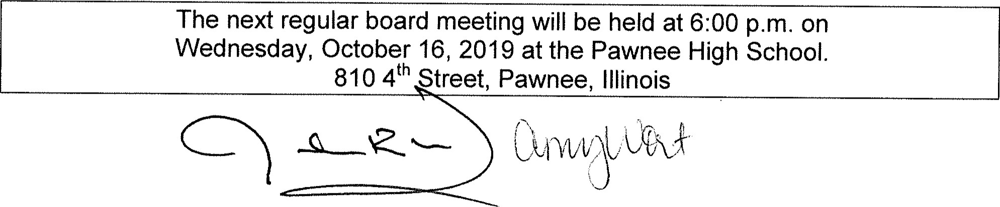

Pawnee Community Unit School District #11
BOARD OF EDUCATION SPECIAL MEETING WORKSHEET

6:00 P.M., TUESDAY, SEPTEMBER 24, 2019
PAWNEE HIGH SCHOOL, PAWNEE, ILLINOIS
l. CALL -ro ORDER

ROLL CALL
A - Wort | A - Ward | P - Shelton | P - Kern
P - Howard | A — Starr | P - McTaggart
Also present:
P - Scott Cameron, Superintendent A Tim Kratochvil, Jr./Sr. High School Principal
A - Chris Hennemann, Grade School Principal
PLEDGE OF ALLEGIANCE
Led by Shelton

APPOINT ACTING SECRETARY
A. Approval to appoint Steve Kern as Acting Secretary.
Motion by Howard, seconded by McTaggart to approval to appoint Steve Kern as Acting Secretary.
Y — Shelton Y — Howard Y — Kern A — Ward
A — Wort A — Starr Y McTaggart
4
BUDGET HEARING

VI. AGENDA ITEMS FOR DISCUSSION AND/OR ACTION
A. Approval of 2019-2020 Budget as presented.
Motion by Howard, seconded by Kern to approve the 2019-2020 Budget as presented.
Y — Howard A - Ward Y — McTaggart A — Wort
Y — Kern A — Starr Y - Shelton
4 — Yes
Shelton is concerned over education fund balance.

ADJOURNMENT
Motion by Howard, seconded by Starr to adjourn the meeting at 6:06 p.m.
Y — Kern A Wort Y — Howard A — Starr
A — Ward Y — Shelton Y — McTaggart
4 — Yes
The next regular board meeting will be held at 6:00 p.m. on Wednesday, October 16, 2019 at the Pawnee High School. 810 4th Street, Pawnee, Illinois
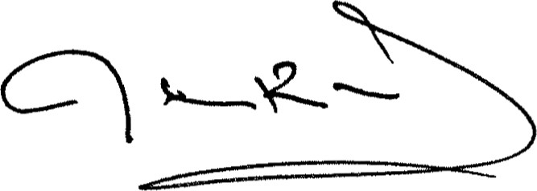 (

Pawnee Grade School
Board Report: October 16, 2019
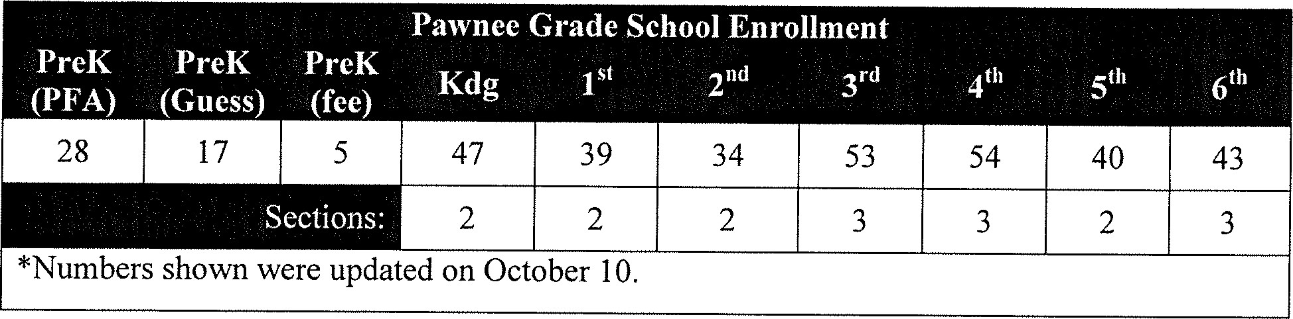
Good News:
- Teachers have conferences scheduled for all of their students. We are looking forward to 100% contact with parents.
Mrs. Boehme received a $250 Scholastic Classroom Library Grant through Scholastic Book Clubs. She will let the students help choose books to fill her classroom library.
Administrative Report:
- Discipline: no out of school suspensions to report
First quarter ended Friday, Oct. I l .
- Parent/Teacher conferences will be held on October 17 and 1
Teacher evaluations are ongoing.
- End of the month assembly was held September 30.
- Planning for our annual Veterans Day program is underway. It will take place on Friday,
November 8. Mrs. Chambers is leading this event that will include a lot of student participation.

PA WNEE COMMUNITY UNIT SCHOOL DISTRICT
810 North Fourth Street, Pawnee, Illinois 62558
Scott Cameron
Superintendent
Phone: 217-625-2471
Timothy R. Kratochvil William C. Hennemann Steven L. Kirby
Jr. High/High School Principal Grade School Principal Athletic Director
Phone: 217-625-2471 Phone: 217-625-2231 Phone: 217-625-2471
October 2019 Junior Hi h/Hi h School Princi al's Re ort
Current Enrollment: High School-177 (183) Junior High-92(85) Total: 269(268) 7th- 460 8th-46(39) 9th-45(39) 10th 49(49) I I ^{th}—44(53) 12th-39(44)
Good News:
- We have 3 Illinois State Scholars: Congratulations to Cassie Bradbury, Dylan Held, Nick Neuber
' Brandon Sharp - fair, honest, polite, hardworking, and helps classmates! Brandon is the son of Mike and Angie Sharp.
- Congratulations to the Pawnee Junior High Students of the Month for September: 8th grader Graydon Jugan, and 7th grader Bailey Bettis.
Personnel:
- One recommendation to hire
Guidance Office Re ort:
Guidance Capital Area Education Fair Field Trip on Wednesday, October 2nd to the Orr Building/Fairgrounds was a success. 36 Juniors participated and had the opportunity to talk with college, technical school, and military representatives.
Guidance/lndustrial Arts took 13 students on a field trip to Southwestern Illinois College in Granite City and Sanks Machining in Staunton. Students toured the campus and machine shop and learned about the value of a trade school education.
PSAT Testing for Juniors will be on October 16th at Pawnee Assembly of God.
- FAFSA Completion Night will be Tuesday, October 22nd, from in Mrs. Ervin's Computer Lab
ROCTE and Work Based Learning (WBL) will present to the Juniors about Job Shadowing opportunities during homeroom on Thursday, October 24th.
CACC will deliver an informative presentation of opportunities at their campus to the Sophomores and Juniors during homeroom on Monday, November 25th.
Academics:
- 2019 Junior High Leadership Conference students; Kinze McTaggart, Zoe Amsden,
Griffin, Boblitt, Maura Harrison, Ava Hernandez, Ashlyn Kern, Riley Schutt, Nick Rice Activities:
Current Job Vacancies o Assistant High School Track
0 7th Grade Junior High Boys Basketball o High School Boys Basketball Assistant
- Extra-Curricular Numbers

PA WNEE COMMUNITY UNIT SCHOOL DISTRICT
810 North Fourth Street, Pawnee, Illinois 62558
Scott Cameron
Superintendent
Phone: 217-625-2471
Timothy R. Kratochvil W. Christopher Hennemann Steven L. Kirby
Jr. HighfHigh School Principal Grade School Principal Athletic Director
Phone: 217-625-2471 Phone: 217-625-2231 Phone: 217-625-2471

2019 October Board Meetin
Contract Year — When would the board like to start negotiations. I will reach out to the union with our thoughts.
Maternity Leave — Mrs. Baker has requested maternity leave. This does not take any board action. I just need to inform the board that has the right under FMLA to take maternity leave. I do believe that Mr. Henneman has a person lined up to fill her spot while she is on leave.
Surplus — Two things to consider are the kitchen brazier and the Toro truck.
Brazier: Kitchen does not use it. Just dry towels on it and could use the space. Toro: It has been sitting outside for a number of years. Needs a new engine and at this point who knows what else. Scott Day said that it was used a lot when it ran but was told to put it outside since the money wasn't going to be spent to fix it
"Radios- I had mentioned these at the beginning of the year. Unfortunately we did not get the grant, but we did budget for the radios. So I am asking the board to give me the okay to start the process of updating our radios.
Internet — We will not get the internet that we thought we were going to get at the beginning of the year. Comcast has put a price of $1 million on the last mile of the project. Stratus is not going to be able to commit to that cost. So we will have to cancel the contract for the lack of not being able to finish the project. We will then start the E-rate process all over again. Best guess would be it will be July of 2020 before we get things going.
95 Hearing waiver The district has exceeded the 5% increase in administrative costs. In talking to Jill it appears that most of that is because of the vacation days paid out to Mr. Alexander. As a result we will need to hold a public hearing as part of the waiver process. I will need to know if we can meet at 5:30 before our next meeting in November or set another date and time.
Levy- I have started working on the Levy. I noticed that the district did not max out its capacity in a few funds last year. I asked Jill about it. We will need to reach capacity this year. The talk of a state wide property tax freeze is starting to pick up steam. So we will need to make sure we are at capacity in case that happens.
A) Special Education — I started researching the cost of special education for this district. It is much higher than my last district. I have a handout to give to the group. 1/7th of our budget is for special education.
cpw

